Finding 1..n numbers sum and avg [ mean ]. 1 to 5 number sum = 15
15/5=3 is avg
Find 1..n even, odd numbers sum
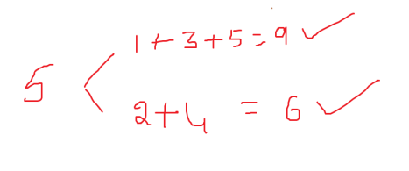
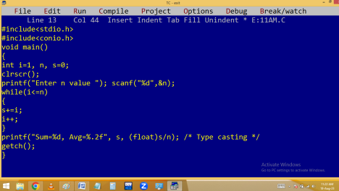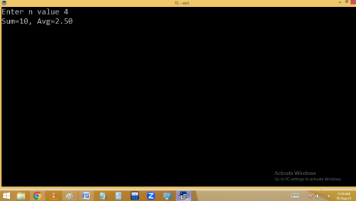
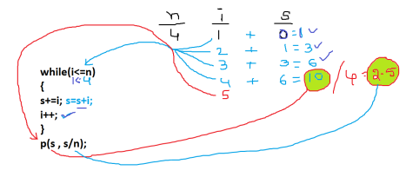Without using a loop:
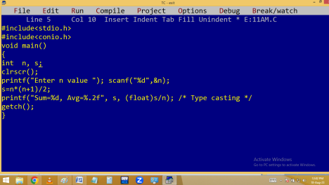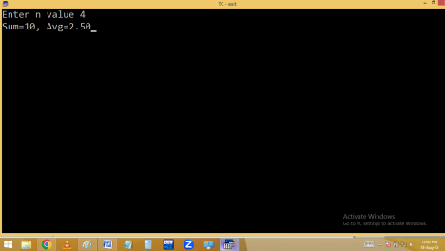
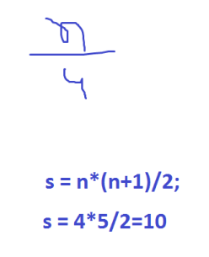Eg. Finding factorial value. eg: 4 factorial is 4*3*2*1=24
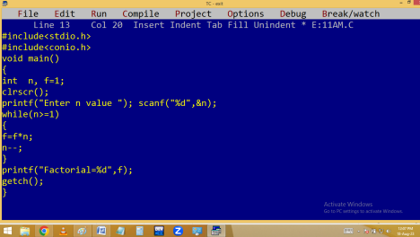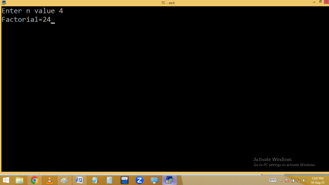
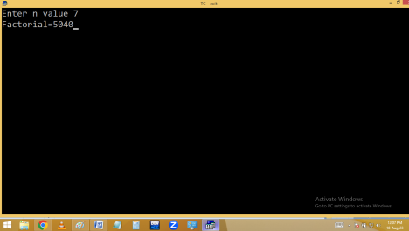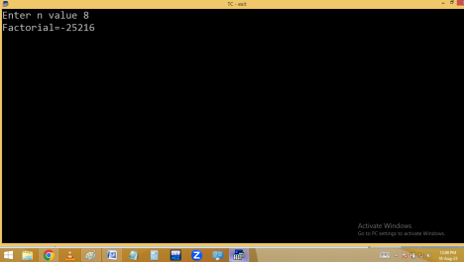
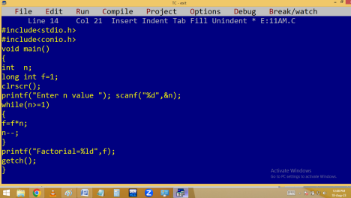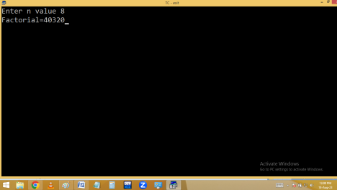
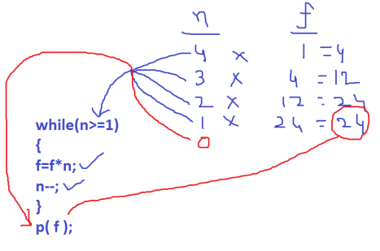Finding power using a user defined program:
Finding powers sum.
2³= 8
2³= 2¹+ 2²+ 2³ = 2 + 4 + 8 = 14
Using pow():
Home work:
Printing first and last digit of given no.
2048 🡺 2 first digit, 8 last digit.
Finding no of digits in given no.
387 🡺 3 digit no
Finding max and min digits of given no. Eg: 29108 🡺 9 max, 0 min

